Digitized mockup – after Guerilla Testing

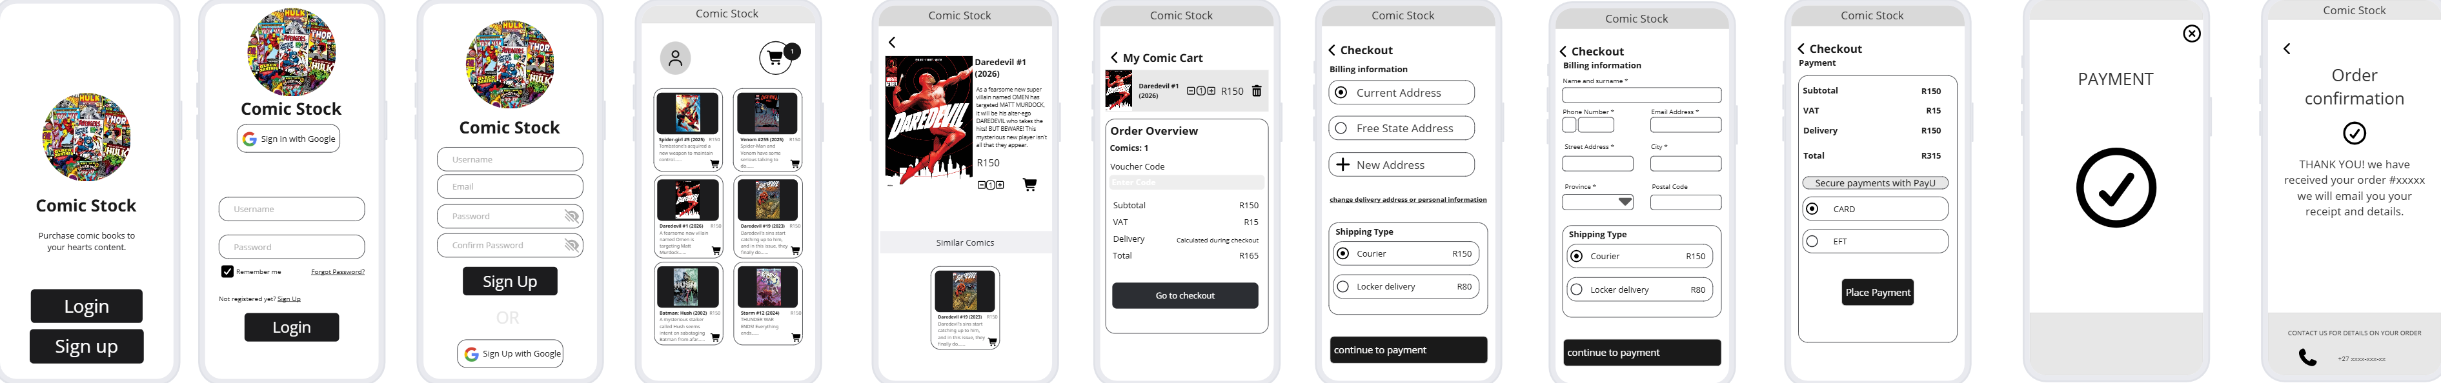

Please use this link to access the miro board for this wireframe

